HayesX -250

Flight Manual

Document No.:
HayesX – 250-FM-001
Revision:
A
Issue Date:
2026
Prepared By:
HayesX Engineering Department

REVISION RECORD

Revision | Date | Description
A | 2026 | Initial Release

TABLE OF CONTENTS

CHAPTER 1
GENERAL INFORMATION
1.1 Purpose 6
1.2 Vehicle Identification 6
1.3 Vehicle Description 6
1.4 Regulatory Statement 9

CHAPTER 2
OPERATING LIMITATIONS
2.1 Airspeed Limitations 10
2.2 Weight Limitations 10
2.3 Load Factor Limits 10
2.4 Attitude Limitations 11
2.5 Battery Limitations 11
2.6 Ballistic Recovery System 11
2.7 Operating Area Limitations 12

CHAPTER 3
EMERGENCY PROCEDURES
3.1 General 14
3.2 Emergency Priorities 14
3.3 Low Battery Warning 14
3.4 Emergency Battery Warning 15
3.5 Single Motor Failure 15
3.6 Multiple Motor Failure 16
3.7 Flight Control System Failure 16
3.8 Control Stick Failure 17
3.9 GPS Signal Loss 17
3.10 Battery Overtemperature 18
3.11 Battery Thermal Runaway 18
3.12 Automatic Flight Function Failure 18
3.13 Ballistic Recovery System Deployment 19
3.14 Ditching Procedure 20
3.15 Pilot Incapacitation 20
3.16 Post Hard Landing Inspection 21

CHAPTER 4
NORMAL PROCEDURES
4.1 General 22
4.2 Preflight Preparation 22
4.3 Preflight Inspection 22
4.3.1 Aircraft Structural Checks 22
4.3.2 Propellers 23
4.3.3 Motors 23
4.3.4 Battery System 23
4.3.5 Ballistic Recovery System 23
4.4 Power-Up Procedure 23
4.4.1 High Voltage System Safety Check - General 24
4.4.2 Preflight Inspection Warning 24
4.4.3 Power-Up Sequence 24
4.4.4 Abnormal Conditions 24
4.5 System Initialization 25
4.6 Propulsion System Check 25
4.6.1 Motor Response Check 25
4.7 Boarding Procedure 25
4.8 Shutdown Procedure 26

CHAPTER 5
AIRCRAFT PERFORMANCE
5.1 General 27
5.2 Basic Performance Data 27
5.3 Electrical System Performance 28
5.4 Hover Performance 29
5.5 Climb Performance 29
5.6 Cruise Performance 29
5.7 Battery Endurance 30
5.8 Range Performance 30
5.9 Wind Speed Limitations 31
5.10 Temperature Envelope 31
5.11 Altitude Range 31
5.12 Load Factor Limits 32
5.13 Performance Notes 32

Revision Date Description
A 2026 Initial Release

CHAPTER 1

GENERAL INFORMATION

1.1 Purpose
This Flight Manual provides operating limitations, normal procedures, emergency procedures, and technical information for the safe operation of the HayesX-250 electric Vertical TakeOff and Landing (eVTOL) aerial vehicle.

1.2 Vehicle Identification
Manufacturer: HayesX Inc. Las Vegas, Nevada, US
Model: HayesX-250
Category: Single-Seat Electric Vertical Takeoff and Landing Aerial Vehicle
Configuration: Quadrotor Octocopter
Propulsion: Electric Propulsion
Occupants: 1 Pilot

1.3 Vehicle Description
The HayesX-250 is a single-seat electric vertical takeoff and landing aerial vehicle utilizing a quadrotor-octocopter configuration.
The primary systems include:
• Aeronautical Aluminum Airframe
• Carbon Fiber Cantilever Structures
• Electric Propulsion System
• Flight Control System
• Battery System
• Complete Aircraft Recovery System
• Flight Data Recording System

HayesX-250 Aircraft:

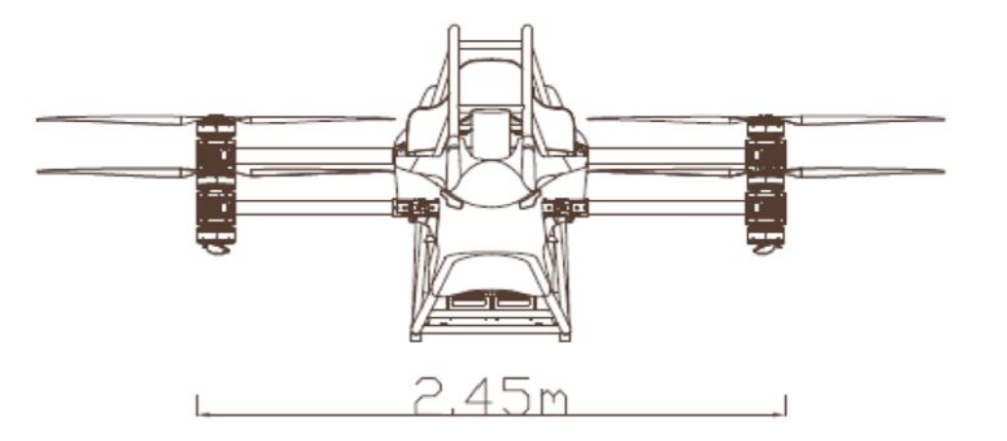
Front View

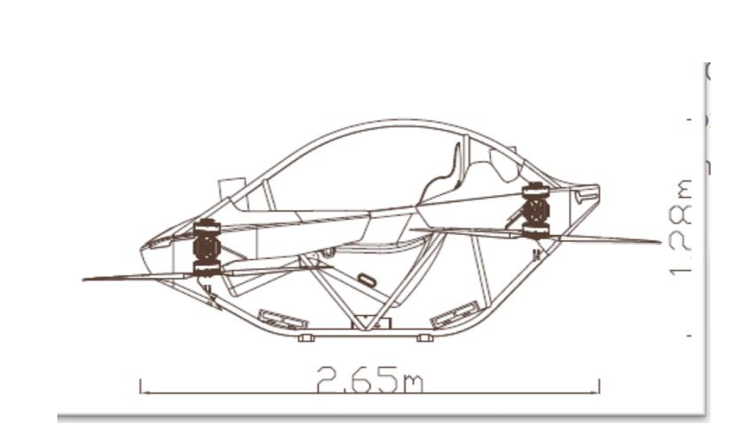
Side View

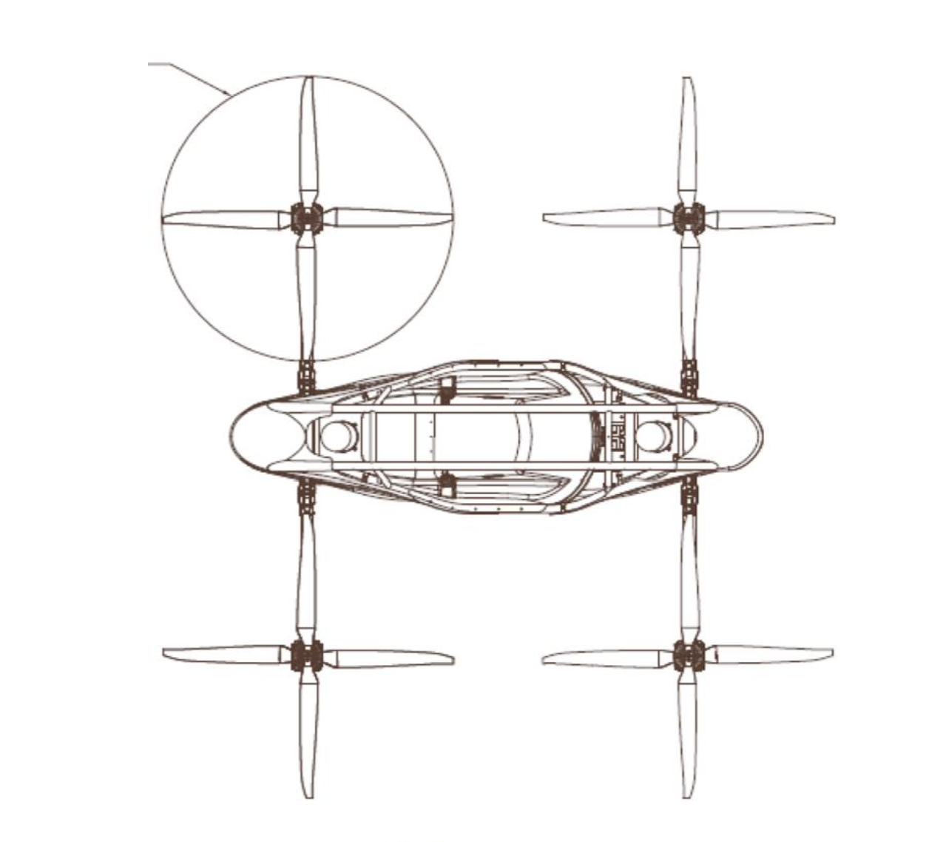
Top View

Propeller Diameter 57” (1.447m)
Maximum Dimensions: 2.655m (Length) x 3.17m (Width) x 1.28m (Height)

Preliminary Technical Specifications:

Parameter: | Details:
Weight | ≤ 116 kg (Excluding rescue system)
Maximum Take Off Weight (MTOW) | 216 kg
Maximum Thrust | 380 kg
Maximum Level Flight Speed | 100 km/h (Software Limitation)
Maximum Flight Time | 25 minutes
Maximum Descent Rate | 4 m/s
Maximum Rate of Climb | 5 m/s
Cruising Range | 20 km
Hover Time | 20 min
Operating Temperature | -10°C~+40°C
Maximum Altitude | 1500 Ft. above ground level (AGL)
Wind Resistance Level | 4 – 6
No. of Motors | 8
Unfolded Dimensions | 2,650 x 2,450 x 1280 mm
Folded Dimensions | 2,650 x 1,380 x 1,280 mm
Crew | 1 Person
Power Source | Electric Lithium Battery

1.4 Regulatory Statement

The HayesX-250 is designed, built, and operated in accordance with the US FAA Part 103 Regulations and CCAR-91-R4 Requirements for Ultralight Vehicles.

Under these Regulations, the HayesX-250 is classified as an Ultralight Vehicle and accordingly:
- No Vehicle Certification is required
- No Airworthiness Certificate is required
- Certification as a conventional aircraft is not required

CHAPTER 2

OPERATING LIMITATIONS

2.1 Airspeed Limitations

Velocity Never Exceed (VNE)

100 km/h
62 mph

Recommended Cruise Speed

40 km/h
25 mph

2.2 Weight Limitations

Maximum Takeoff Weight

216 kg

Maximum Pilot Weight

100 kg

Minimum Pilot Weight

No Restriction

2.3 Load Factor Limits

Positive Limit Load

+2.0 G-force

Negative Limit Load

-2.0 G-force

Ultimate Load

+3.0 G-force – 2.0 G-force

2.4 Attitude Limitations

Maximum Roll Angle

30°

Maximum Pitch Angle

30°

2.5 Battery Limitations

Minimum Battery Before Takeoff

95%

Minimum Battery Before Landing

35%

Emergency Battery Warning

30%

Immediate landing required.

2.6 Ballistic Recovery System

Model

GBS 10M

Maximum Deployment Speed

100 km/h

Minimum Recommended Deployment Height

10 m AGL

Activation Handle Location

Located on the pilot's left side.

WARNING

Once activated, parachute deployment cannot be cancelled.

The aircraft parachute has a 6-year validity period. At the expiry of the period, please contact the aircraft manufacturer for inspection. This entire aircraft rescue system is a pyrotechnic device and must be disassembled and/or repaired by authorized personnel only.

2.7 Operating Area Limitations

Visual Flight Rules (VFR):

HayesX-250 shall be operated only under Visual Flight Rules (VFR).

The pilot shall maintain continuous visual awareness of surrounding airspace, terrain, obstacles, and other aircraft.

Weather Limitations:

Flight is permitted only under Visual Meteorological Conditions (VMC).

Flight is prohibited under:

- Flight in clouds
- Dense fog
- Heavy rain
- Thunderstorm activity
- Known icy conditions

Daylight Operations:

HayesX-250 is approved for daytime operations only.

Night operations are prohibited unless specifically authorized by the applicable aviation authority.

Airspace Limitations:

The pilot shall comply with all applicable national and local airspace regulations. Prior to entering controlled airspace, approval or clearance shall be obtained from the appropriate Air Traffic Control (ATC) authority.

Unauthorized entry into the following areas is prohibited:

• No-fly Zones（Prohibited Areas）
• Restricted Areas
• Danger Areas
• Temporary Flight Restriction Areas

Congested Area Restrictions:

Flight over densely populated areas is prohibited unless specifically authorized by applicable regulations.

Adequate separation shall be maintained from persons, vehicles, buildings, and property at all times.

Safe Operating Area:

Operations should be conducted within designated and evaluated flight areas.

Recommended operating areas include:
  - Open terrain
- No overhead power lines present
- No significant obstacles from tall buildings
- No large congregations or dense public gatherings
- Area meets suitable emergency landing requirements

CHAPTER 3

EMERGENCY PROCEDURES

3.1 General

In any emergency, the pilot shall first maintain controlled flight.

The pilot shall then identify the malfunction and take appropriate corrective action.

If controlled flight cannot be maintained, immediate consideration shall be given to deployment of the Ballistic Recovery System (BRS).

3.2 Emergency Response Principles

Recommended emergency response priority:

- Maintain vehicle control
- Select safe landing area

- AUTO LAND

- RETURN TO HOME (RTH)

- Manual Landing

- BRS Deployment

3.3 Low Battery Warning

A warning is sounded when the battery is less than or equal to 35%.

On hearing the warning, you should immediately respond by:

- Terminating the Current Task
- Prepare to land
- Reduce large scale maneuvers
- Monitor power continuously

The Battery Level Display in the upper level of the PFD will trigger an audible alarm when the battery goes below 35%.

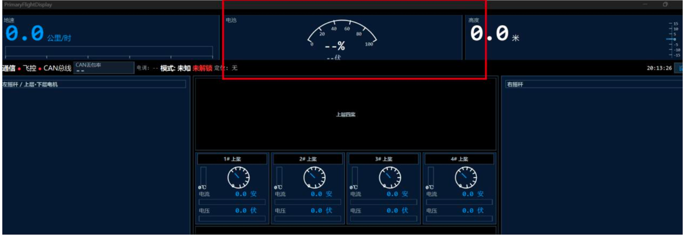

3.4 Emergency Battery Warning

A further warning is sounded when the battery is less than or equal to 30%.

On hearing the warning, you should immediately respond by:

- Finding the nearest safe place to land
- Perform Landing
- No Further Flight Allowed.

The Battery Level Display in the upper level of the PFD will trigger an audible alarm when the battery goes below 30%.

3.5 Single Motor Failure

Indication to Pilot:

A single motor stops working or is providing abnormal thrust.

In the event of a single motor failure, the pilot should respond immediately and keep the aircraft stable by:

- Reducing flight speed
- Lowering flight altitude
- Choosing a safe landing area, and
- Landing as soon as possible

Follow up actions:

- End of flight
- Do not take off again

3.6 Multiple Motor Failure

Indication to Pilot:

Two or motor motors fail.

In the event of a multiple motor failure, the pilot should respond immediately and:

- Determine whether the aircraft is controllable
- If under control, land immediately
- If it is or becomes uncontrollable, activate BRS immediately.

3.7 Flight Control System Failure

In the event of a Flight Control System failure, the Pilot should respond immediately by:

- manually operating the joystick to land
- Selecting the nearest safe landing area
- Performing the landing

If you cannot control the aircraft by operating the joystick:

- Activate the BRS whole-aircraft parachute rescue system immediately.

3.8 Control (Joystick) Stick Failure

Indication to Pilot:

Aircraft will not respond to joystick controls

In the event of joystick control failure, the pilot should immediately:

- Confirm that the flight control system is normal
- Open the virtual PFD joystick interface
- Start Virtual Stick Mode
- Control the aircraft using the virtual joysticks
- Find a safe landing area
- Land as soon as possible

Follow Up Action:

No further flight allowed

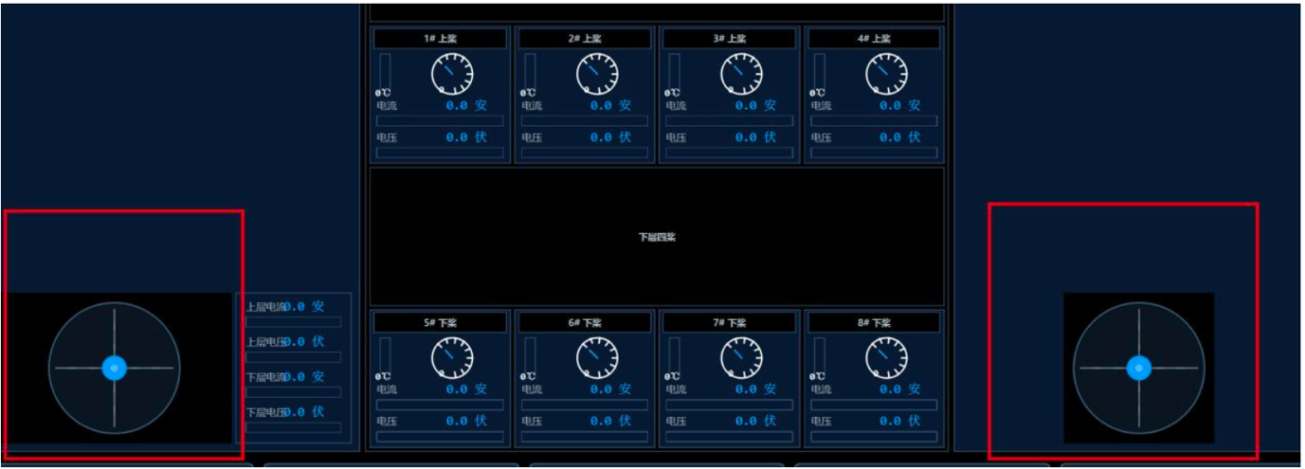

3.9 GPS Signal Loss

In the event of GPS signal loss, the pilot should immediately:

- Maintain visual flight
- Switch attitude mode

3.10 Battery Overheating

In the event of the battery overheating, the pilot should immediately:

- Reduce power
- Terminate mission
- Land as soon as possible
- Shut down main power after landing

3.11 Battery Thermal Runaway

In the event of a Battery Thermal Runaway as a result of:

- Smoke
- Abnormal smell
- Sharp rise in temperature

The pilot should:

- Land immediately
- Stay away from crowded areas
- Evacuate immediately after landing

Do not restart the system

3.12 Automatic Flight Function Failure

Automatic Flight Function Failure applies when:

- AUTO LAND is not working
- Return To Home (RTH) function failure
- Auto Navigation Exception
- Auto Flight Interruption

In these circumstances, the pilot should immediately:

- Switch to manual mode
- Keep the aircraft stable
- Select the nearest safe area to land, and
- Manually land immediately

Follow up actions:

- No further flight allowed
- Prohibited from taking off again
- Complete system check

Warning:

Do not continue flight missions after a flight function failure.

3.13 Parachute Activation Procedure (Ballistic Recovery System BRS)

The parachute is deployed by the pyrotechnic driven piston system. The pre-flight checklist should ensure that the parachute red cover is unobstructed. Deployment of the BRS to be undertaken in the following situations:

- Flight control failure
- Multiple motor failure
- Structural damage
- Aircraft out of control

Remediation Actions:

- Stop using joystick and/or digital flight controls
- Pull the red start parachute handle on the left
- Wait for parachute to fully deploy
- Brace for landing

After Landing:

- Turn off main power
- Evacuate the aircraft

3.14 Ditching Procedure

Restrictions:

It is not approved or recommended for HayesX-250 to be flown over water

In the event that you are flying over water and you have a catastrophic event, please follow the emergency procedure:

- Stay calm and in control
- Minimize the speed of descent
- Brace for impact with the water
- Turn off power immediately after contact with the water surface
- Unfasten your seat belt and evacuate

3.15 Pilot Incapacitation

In the event the pilot is somewhat incapacitated, has a panic attack, or is otherwise unable fly the aircraft, every effort should be made to immediately to:

- Maintain a stable aircraft
- Assess your own status

Your options are:
- Auto Land
- Return to Home (RTH)
- BRS.

To land the aircraft automatically with Auto Land, press the PFD automatic landing button.

To return to home, press the PFD return to home button.

If unable to operate Auto Land or Return to Home, activate the BRS.

3.16 Post Hard Landing Inspection

The HayesX-250 must be grounded in the following circumstances:

- Landing gear damage
- Structural damage
- Aircraft capsizes
- Blade grounded
- Parachute deployed
- Battery shock

Flights may resume only after inspection and release by authorized HayesX personnel.

Chapter 4

Normal Operating Procedures & Checklist

4.1 General

This chapter details the checklist and normal operating procedures for the HayesX-250.

It is important to perform all procedures in the sequence outlined in the checklist.

All pilot operations and movements must be within the Formula 1 inspired roll cage. In the interest of pilot safety, no arm movements permitted outside the roll cage.

4.2 Preflight Preparation

The pilot shall verify:

- Flight Manual has been reviewed
- He/she is physically fit for flight
- Is not under the influence of alcohol or drugs
- The weather suitable for VFR
- It is permissible to fly in the proposed area
- The battery is fully charged
- The flight is fully planned

4.3 Preflight Inspection & Checklist

4.3.1 Aircraft Structural Checks:

- Ensure no structural cracks
- Check cantilever arms are undamaged
- Ensure cantilever arms secure and rigid at joints
- Landing gear serviceable
- All critical fasteners marked with red torque-seal paint are secure and show no signs of loosening, fracture, or misalignment.

4.3.2 Propellers:

- Check all propellers are intact
- Ensure there are no cracks
- Check to ensure no deformation
- Make sure they are securely attached
- Check propeller tie wire fixing is intact
- Check all marked joints show no evidence of movement or misalignment.

4.3.3 Motors:

- Ensure Motors Rotate freely
- Check to ensure no excessive play
- Ensure there are no foreign objects

4.3.4 Battery System

- Secure front batter
- Secure rear battery
- Check to ensure no bulge in the battery
- Check for any physical damage

4.3.5 Ballistic Recovery System (BRS) / Parachute

- Safety pin removed Question for Ben – should the safety pin be removed before flight?
- System on standby
- Activation handle unobstructed

4.4 Power-Up Procedure

Main Power Connection

- Confirm both main power connectors are disconnected
- Connect Front Battery QS12 Main Power Connector
- Verify secure connection
- Connect Rear Battery QS12 Main Power Connector
- Verify secure connection

4.4.1 High Voltage System Safety Check - General

HayesX-250 utilizes a dual 108V DC electrical power system.

The front and rear battery packs are connected to the aircraft’s main power system through QS12 high-voltage connectors.

High-voltage system maintenance shall only be performed by trained personnel.

4.4.2 Preflight Inspection

Verify:
- QS12 connectors undamaged and in good condition
- No burn marks
- No thermal deformation
- No mechanical damage
- Locking mechanism is normal and functional
- High-voltage cable insulation intact
- No exposed conductors

4.4.3 Safety Warning

- Do not connect or disconnect QS12 connectors under electrical load.
- Do not short-circuit battery terminals.
- Do not operate with damaged connectors.

4.4.4 Abnormal Conditions

If any of the following occurs:

• Abnormal arcing
• Burning smell
• Connector overheating
• System startup failure

Disconnect power immediately and discontinue operation.

4.5 System Initialization

After both battery systems are connected, the Flight Control System powers up automatically.

- Flight Control System ON
- PFD ON
- Flight Data Recorder ON
- Wait for self-test completion

4.6 Propulsion System Check

Propulsion System Status Check:

Inspect all eight propulsion arm control modules:

- Eight green status indicators illuminated continuously
- No red fault indicators
- No warning tones
- No fault messages displayed

4.6.1 Motor Response Check

- Motor response normal
- No abnormal vibration
- No abnormal noise

4.7 Boarding Procedure

- Ensure aircraft is stable and secure before boarding
- Board aircraft
- Fasten restraint harness
- Check PFD display
- Ensure Battery Charge ≥95%
- No error warnings

4.8 Shutdown Procedure

- Stop motors and secure aircraft
- Disconnect Rear Battery QS12 Main Power Connector
- Disconnect Front Battery QS12 Main Power Connector
- System Shutdown
- Following main power disconnection, the Flight Control System, PFD, and Flight Data Recorder will automatically shut down.
- Verify complete system shutdown
- Disconnect cantilever arm brackets
- Fold cantilever arms
- Insert cantilever joint protectors
- Store eVTOL

CHAPTER 5

AIRCRAFT FLIGHT PERFORMANCE

5.1 General

This chapter provides performance information for the HayesX-250 Electric Vertical Takeoff and Landing Aerial Vehicle. All performance data is based on engineering analysis, ground testing, and flight test results. Performance figures are provided for flight planning purposes only. Actual performance may vary depending on pilot weight, temperature, wind conditions, battery condition, and altitude.

5.2 Basic Performance Data

Aircraft Model:

HayesX-250

Aircraft Type:

Single-Seat eVTOL Aerial Vehicle

Empty Weight:

116 kg

Maximum Takeoff Weight (MTOW):

216 kg

Maximum Pilot Weight

100 kg

Maximum Level Flight Speed

100 km/h
62 mph

Recommended Cruise Speed

40 km/h
25 mph

Maximum Operating Altitude

1500 ft AGL
457 m AGL

5.3 Electrical System Performance

System Voltage

108 VDC

Battery Architecture

Dual Independent Battery Packs

Maximum System Current

320 A

Maximum Battery Current

160 A

Maximum Continuous Power

35 kW

Maximum Peak Power

40 kW (Not exceeding 10 seconds)

5.4 Hover Performance

Standard Conditions:

Sea Level

ISA Standard Atmosphere

MTOW 215 kg

Hover In Ground Effect (IGE)

0 – 2m

Recommended Hover Height

2 – 10m AGL

Typical Hover Power

24 – 28 kW

5.5 Climb Performance

At Maximum Takeoff Weight

Recommended Rate of Climb

2 – 3 m/s

394 – 591 ft/min

Maximum Short Duration Climb Rate

4 m/s

787 ft/min

5.6 Cruise Performance

Recommended Cruise Speed

40 km/h

Economy Cruise Power

22 – 26 kW

Typical Cruise Current

200 – 250 A

5.7 Battery Performance

The following data applies to:

Standard Atmosphere

Calm Wind Conditions

Battery is Charged to >95%

Typical Battery Endurance

20 – 25 min

Maximum Planned Battery Endurance

30 min

Minimum Battery Power Required for Landing

25%

5.8 Range Performance

Economy Cruise Conditions

40 km/h

Typical Range

12 – 15 km

Maximum Planned Range

20 km

5.9 Wind Speed Limitations

Maximum Sustained Wind Speed

8 m/s

16 kt

Maximum Gust

10 m/s

19 kt

Flight is prohibited above these limits.

5.10 Temperature Range

Operating Temperature Range

-10°C to +40°C

14°F to 104°F

Recommended Temperature Range

10°C to 30°C

50°F to 86°F

5.11 Altitude Range

Maximum Operating Altitude

1500 ft Above Ground Level (AGL)

457 m AGL

Recommended Operating Altitude

Below 500 ft AGL

5.12 Load Factor Limits

Maximum Positive Load:

+2.0 G-Force

Maximum Negative Load:

-2.0 G-force

Ultimate Load
±3.0 G-force

5.13 HayesX-250 Performance

- Performance may be affected by:
- Pilot Weight
- Ambient Temperature
- Wind Speed and Direction
- Battery Health
- Operating Altitude
- Flight Maneuvering Intensity

Performance may be reduced in high-temperature, high-altitude, or high-wind
environments.

Adequate performance margins shall be maintained for safe operation.

